**Survey Station Relocations**

The southern Gulf snow crab annual survey has a 34-year history, from initial exploratory forays in 1987 and 1988 up to the present. Over this period, the survey has undergone multiple expansions of its survey area, as well as changes in spatial sampling design. Details on the sampling protocol and development of this survey can be found in Moriyasu et al. 2008.

The spatial sampling design is based on randomly selected sampling stations within a regular grid overlaying the survey area. From 1988 to 2011, rectangular 10’x10’ grids were used and subsequently replaced square of square grids in 2012 onwards. Large subsets of sampling stations were fixed (i.e. resampled) from year to year, though new sampling stations were continually added through survey expansions, relocation of sampling stations from difficult to more favourable trawling locations, and in response to changes in spatial sampling design in 1991, 2006, and in 2012 and 2013.

**Figure 1** shows a generated historical summary of the complete set of sampling stations used in the snow crab surveys from 1988 to 2020. Stations lying within a 1.5 km distance of each other were labelled as belonging to the same sampling station.

From an initial set of stations in 1988, this figure shows that stations were added or redistributed over most years of the survey. In particular, new stations were rapidly added in the early part of the survey, which had its greatest areal expansion from 1988 to 1993. Only a partial survey was conducted in 1996 due to lack of funding.

The period from 1994 to 2005 saw progressively smaller proportions of stations being re-located, in part due to improvements in geo-location technologies and a general tendency to relocate stations from difficult trawling areas to areas within its sampling grid more suitable to trawling.

After a major survey sampling redesign in 2006, which saw a redistribution of stations in order to have a more uniform spatial distribution over the survey area, the set of sampling stations remained constant from 2006 to 2011, indicating that the survey crews heavily favoured resampling after a failed tow attempt, rather than relocating at an alternate sampling station.

Following another spatial sampling design change in 2012, a completely new set of 325 survey stations were generated. The process was repeated in 2013 with 355 stations. From 2013 onward, sampling stations remained fixed, but the survey crew favoured sampling at alternate stations, rather than repeating tows after a failed attempt at towing.

**Figure 2** shows the proportion of failed tows for each survey year. In 2012 and 2013, ~17% and ~20% of attempted tows failed on the first attempt. Given that the spatial sampling density over the survey area is fairly uniform, these proportions also represent the proportion of the current survey area which is trawlable on the first attempt.

These proportions of rejected tows were higher than in previous years, which were around 9.5% to 11.7% in 2006 to 2011. Largely because of this, the trawl stations were held fixed from 2013 onward, with the proportion of failed tows again decreasing as alternate sampling stations replaced many stations from the original 2013 station set.

**Figure 3** shows where the relocations have occurred, indicating that problematic areas lie mostly between Prince Edward Island and the Magdalen Islands and along the Laurentian Channel.

**Table 1** shows a detailed breakdown of the number of survey grids, out of a total 355, which have had a specified number of sampling station relocations, between the 2013 and 2020 surveys.

In particular, 67 stations from the original set of 355 random stations in were moved to alternates in 2013. Progressively more and more grids contained relocated stations, though the number of original stations being moved has decreased to about 11 per annum in the past 4 years. In 2020, only 186 from the original 2013 stations remained fixed, with 80 of the remaining stations moving once, 33 moving twice, 29 moving three times, and 27 moving four or more times.

As an indicator of possible increasing biases over 2013 to 2020, survey grids were divided into two groups: grids whose stations remained fixed and those whose sampling station had moved at least once. The average densities were calculated for each group and the annual ratio between moved versus fixed was calculated. Four variables were selected for analysis: male and female instar VIII, commercial recruits, and mature females. For male and female instar VIII, the ratio gradually shifted from 40-60% to near parity from 2017 onwards. The pattern was similar for commercial fishery recruits, shifting from y shifted from 45% to ~90% for the last four years. In contrast, mature females showed less variation, remaining between 50% and 65%, with no overall trend over the period.

The shifts observed for instar VIII and commercial recruits described above lends some support to the hypothesis that survey sampling bias may be increasing in conjunction with the increasing proportion of survey stations on trawlable bottoms. However, mature females do not show a similar shift and these may also be driven by natural processes, such contrasting recruitment or migration between different survey areas. In addition, the spatial distribution of fixed stations is not random, reflecting areas of known trawlability, and thus is more subject to local effects.

**CONCLUSION**

Almost half of survey stations have been moved at least once since 2013. Although the relocated station are chosen randomly within their respective grids, stations over time will naturally gravitate towards locales with lower probability of trawl damage. Thus, as stations locations settle onto more trawlable bottom, the probability of trawl damage will tend to decrease over time, as was observed over the period from 2013 to 2020. A similar decrease is observed for the period preceding the 2006 survey.

Different types of sea bottom reflect different habitats and likely contain different crab densities and possibly trawl catchability. Investigations on change in ratios between fixed and moved stations suggested some evidence of increasing catchability for instar VIII and commercial recruits, but remain inconclusive due to a contrasting trend for mature females and the known presence of confounding natural processes.

To monitor the impact of survey station relocations over time on abundance and biomass estimates, it is recommended that a representative subset (say about half of the stations) of the original 2013 set of random survey stations be chosen to remain fixed in subsequent surveys, while the remaining stations may be relocated as per the current protocol. This protocol change will allow for monitoring and will also provide a means to correct drift between the two portions of the data if detected.

True fixed station sampling was used for this survey from 2006 to 2011, which maintained its entire set of designated sampling stations throughout, with a tow rejection rate of 10.8% overall. However, though this rejection rate may be deemed acceptable, we note that more than half of these survey stations were retained from the set used in 2005, which presumably had undergone the same station relocation process mentioned above.

Given that the tow rejection rate for 2013 was 20.7% and that of 2020 was 9.7%, we estimate that holding 50% of sampling stations as fixed will yield a rejection rate of ~15%. Smaller numbers of fixed stations will lower the rejection rate, but will lower the statistical power of the fixed stations as a control measure.

**Here!**

Macintosh HD:Users:crustacean:Desktop:Stock-Assessment-2020:results:figures:Survey Station History.pdf

**Figure 1**: Historical cumulative summary of sampling stations added during the annual southern Gulf of Saint Lawrence snow crab survey. Shaded lines indicate that a station was successfully sampled for a particular year. The y-axis shows the order of appearance of sampling stations, with older sampling stations found near the bottom and the most recent stations near the top. Annotations show major changes in survey sampling design.

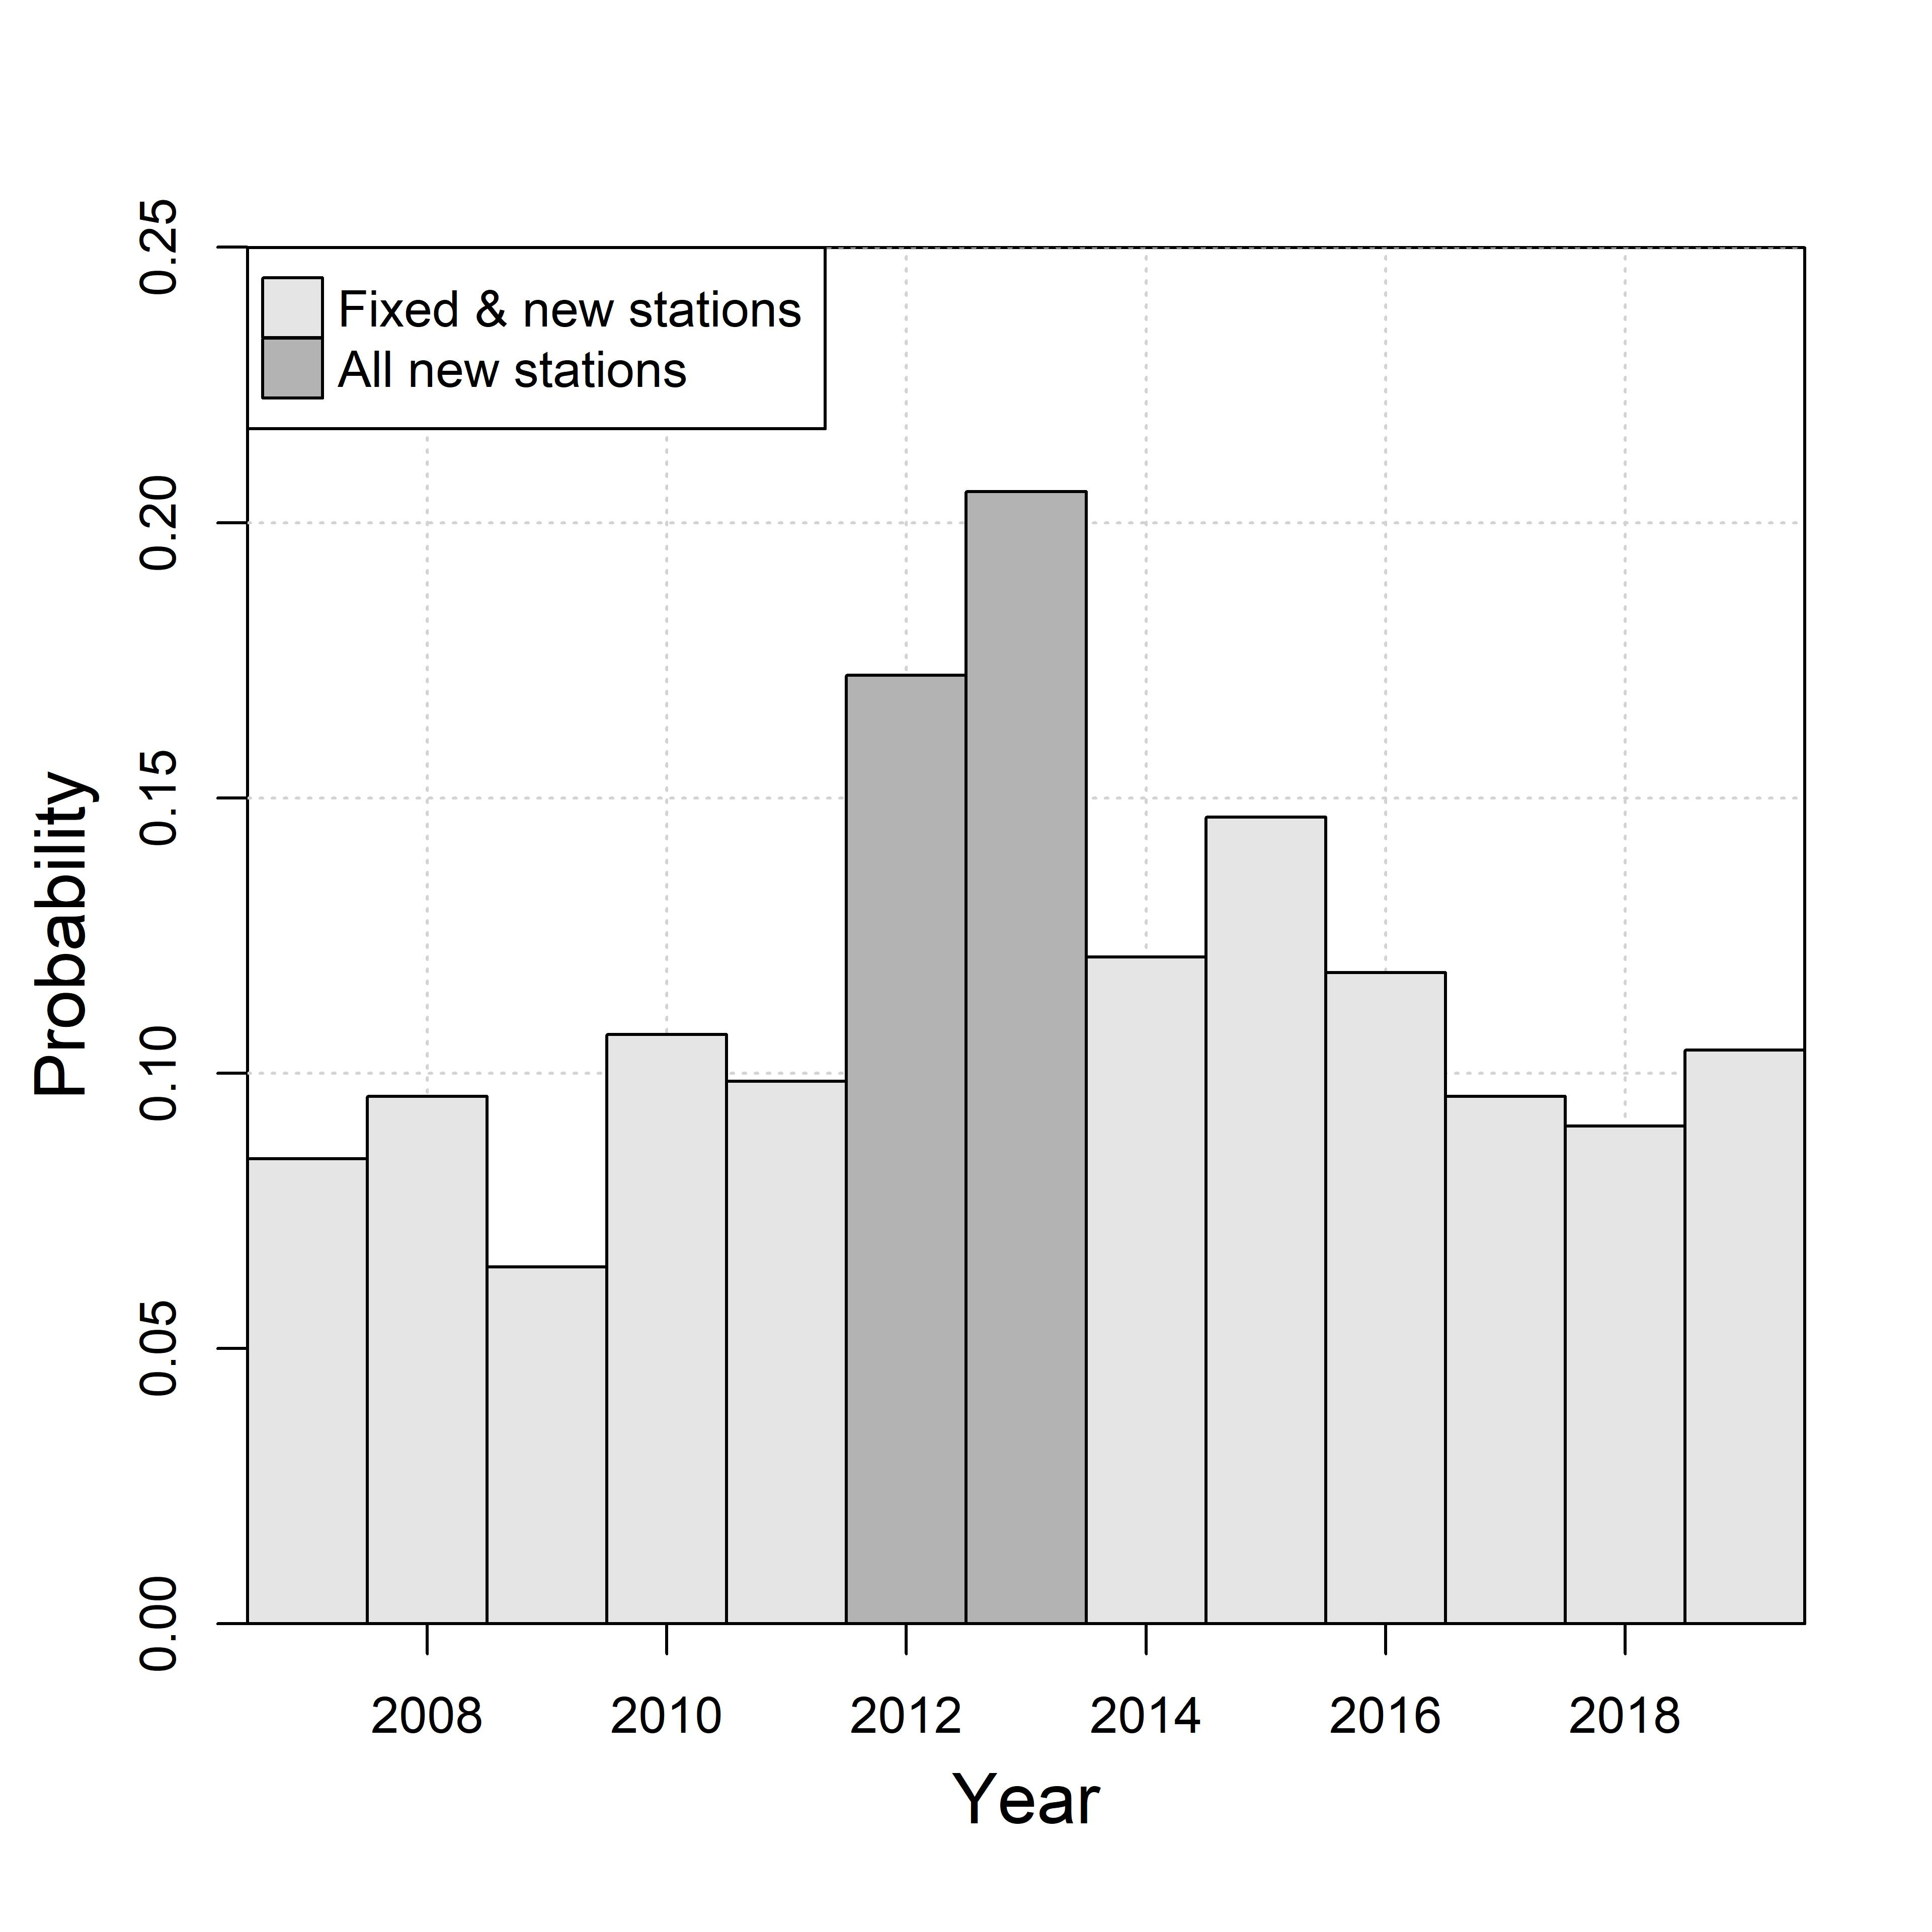

**Figure 2**: Proportion of tows rejected on the first attempt during the 2007 to 2019 snow crab surveys.

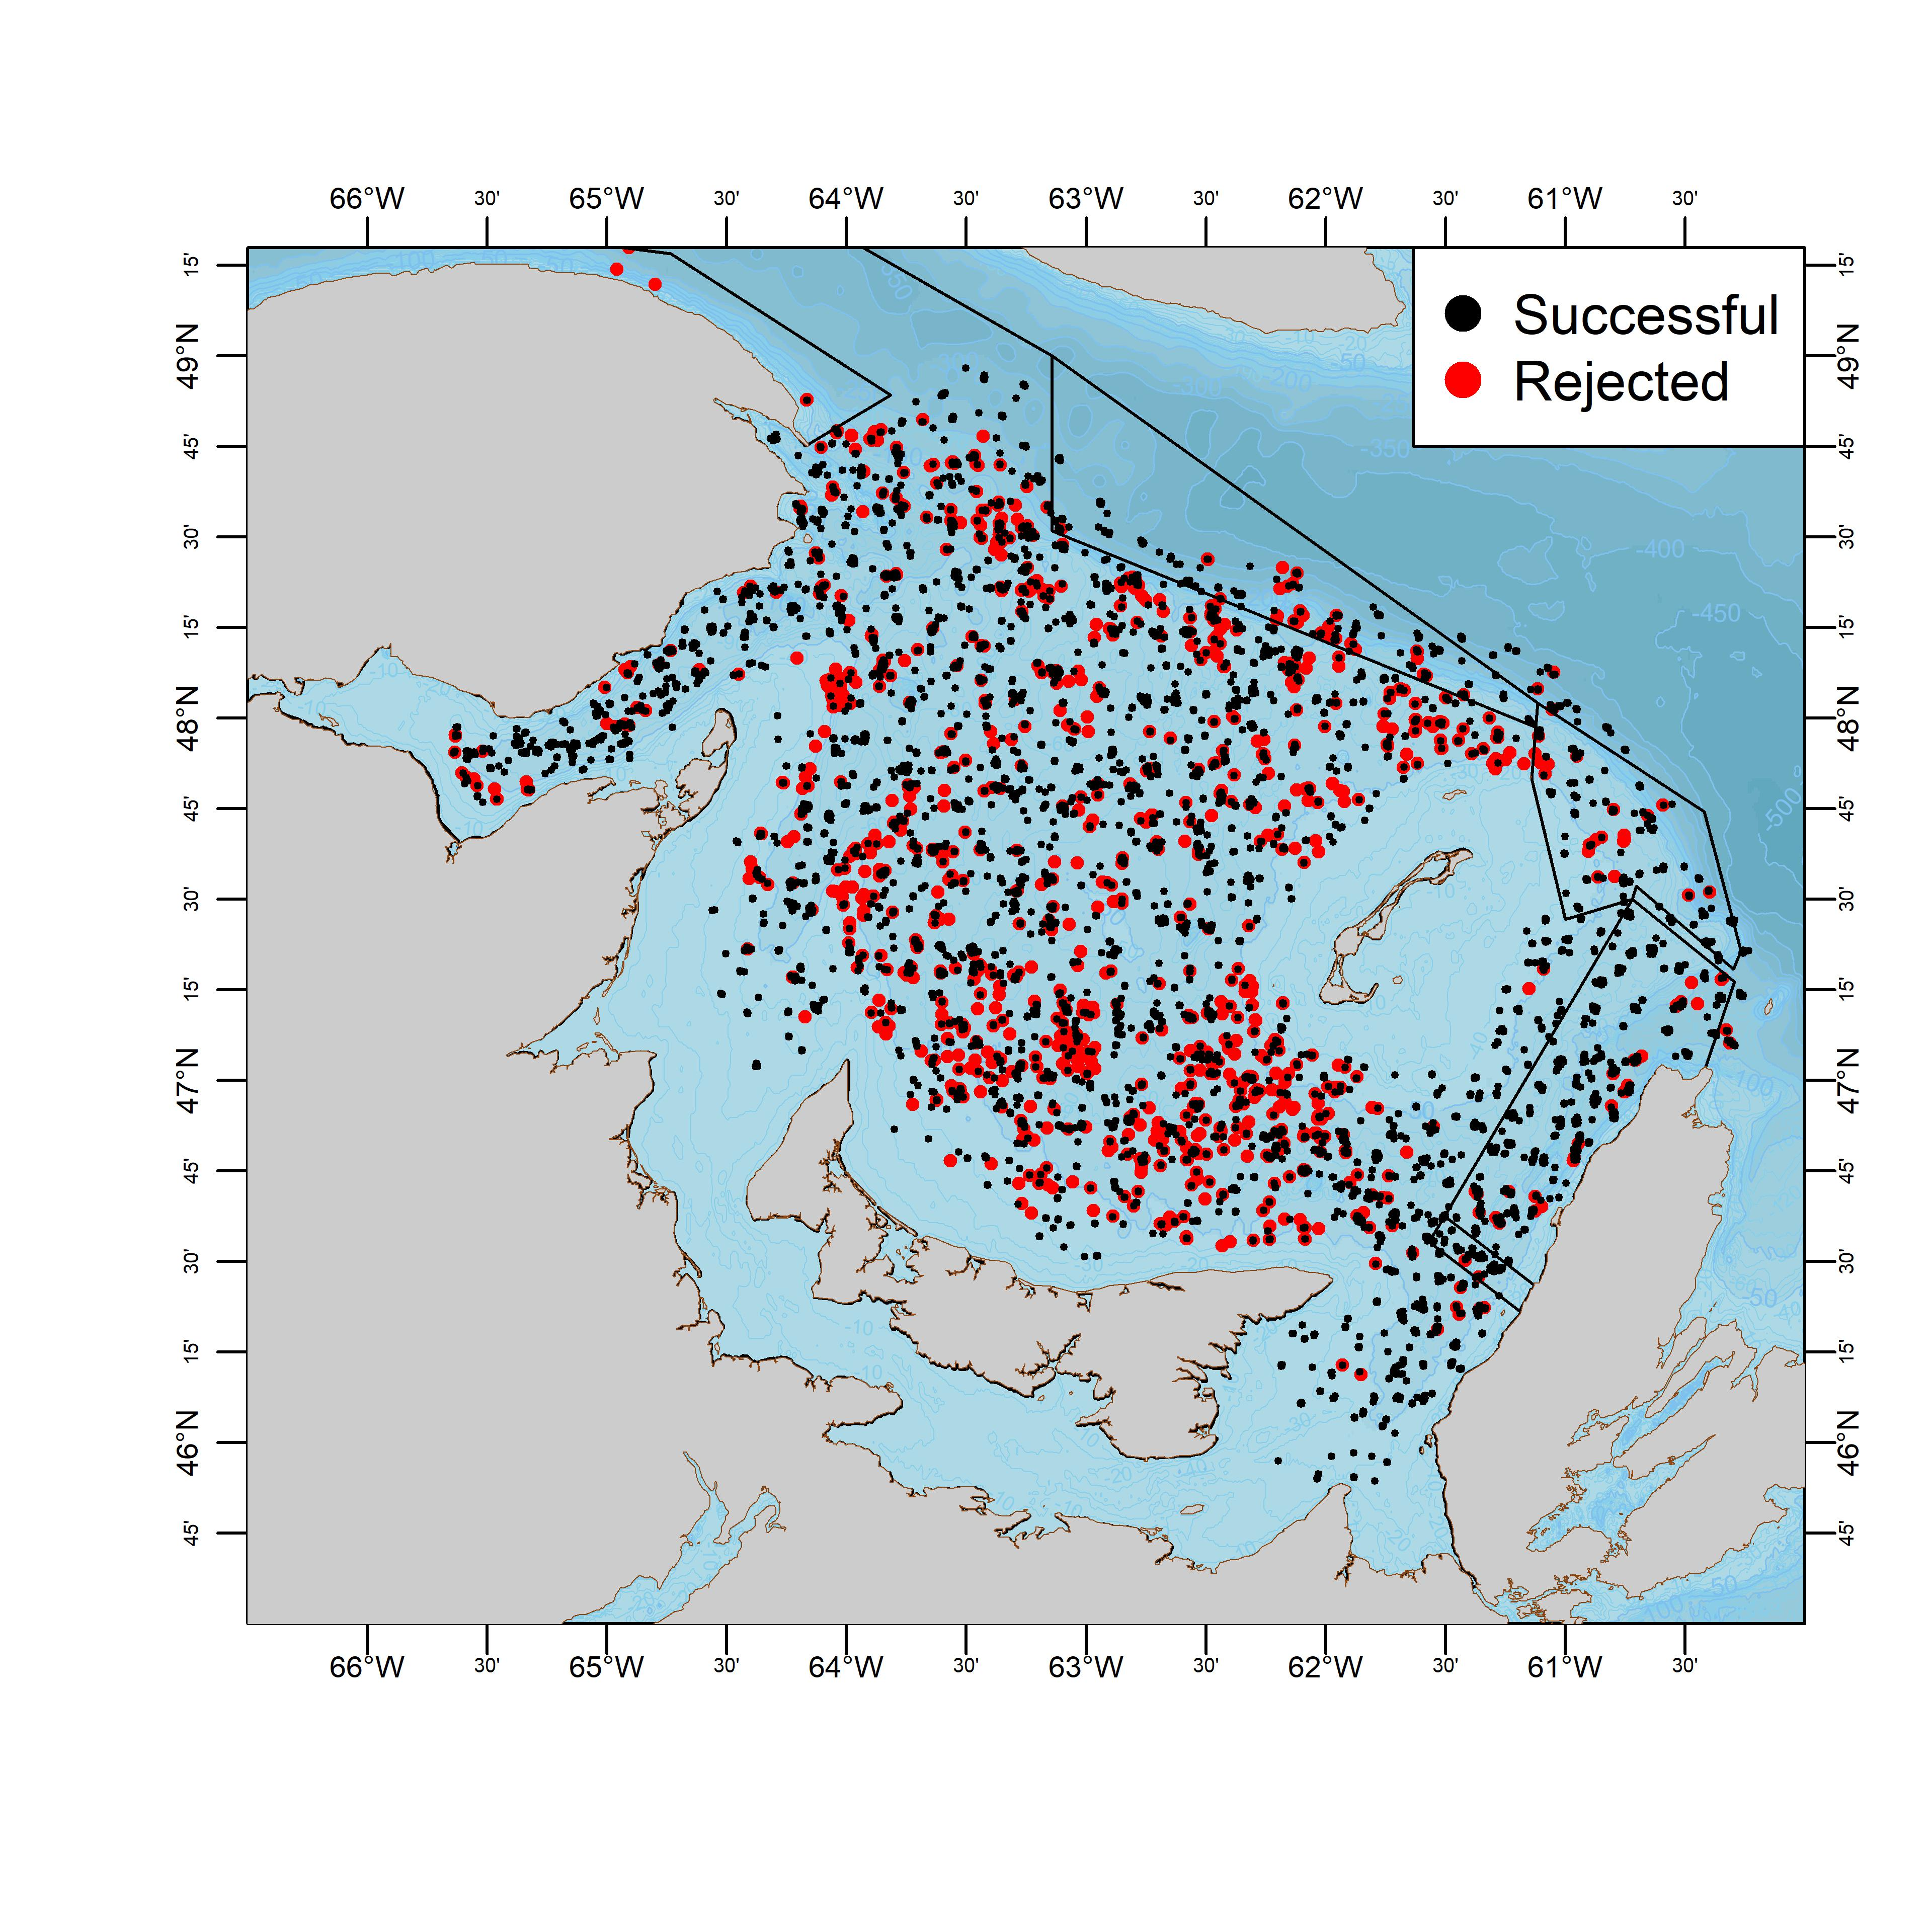

**Figure 3**: Locations of successful (black) and rejected (red) tows in the 2000 to 2019 snow crab surveys.

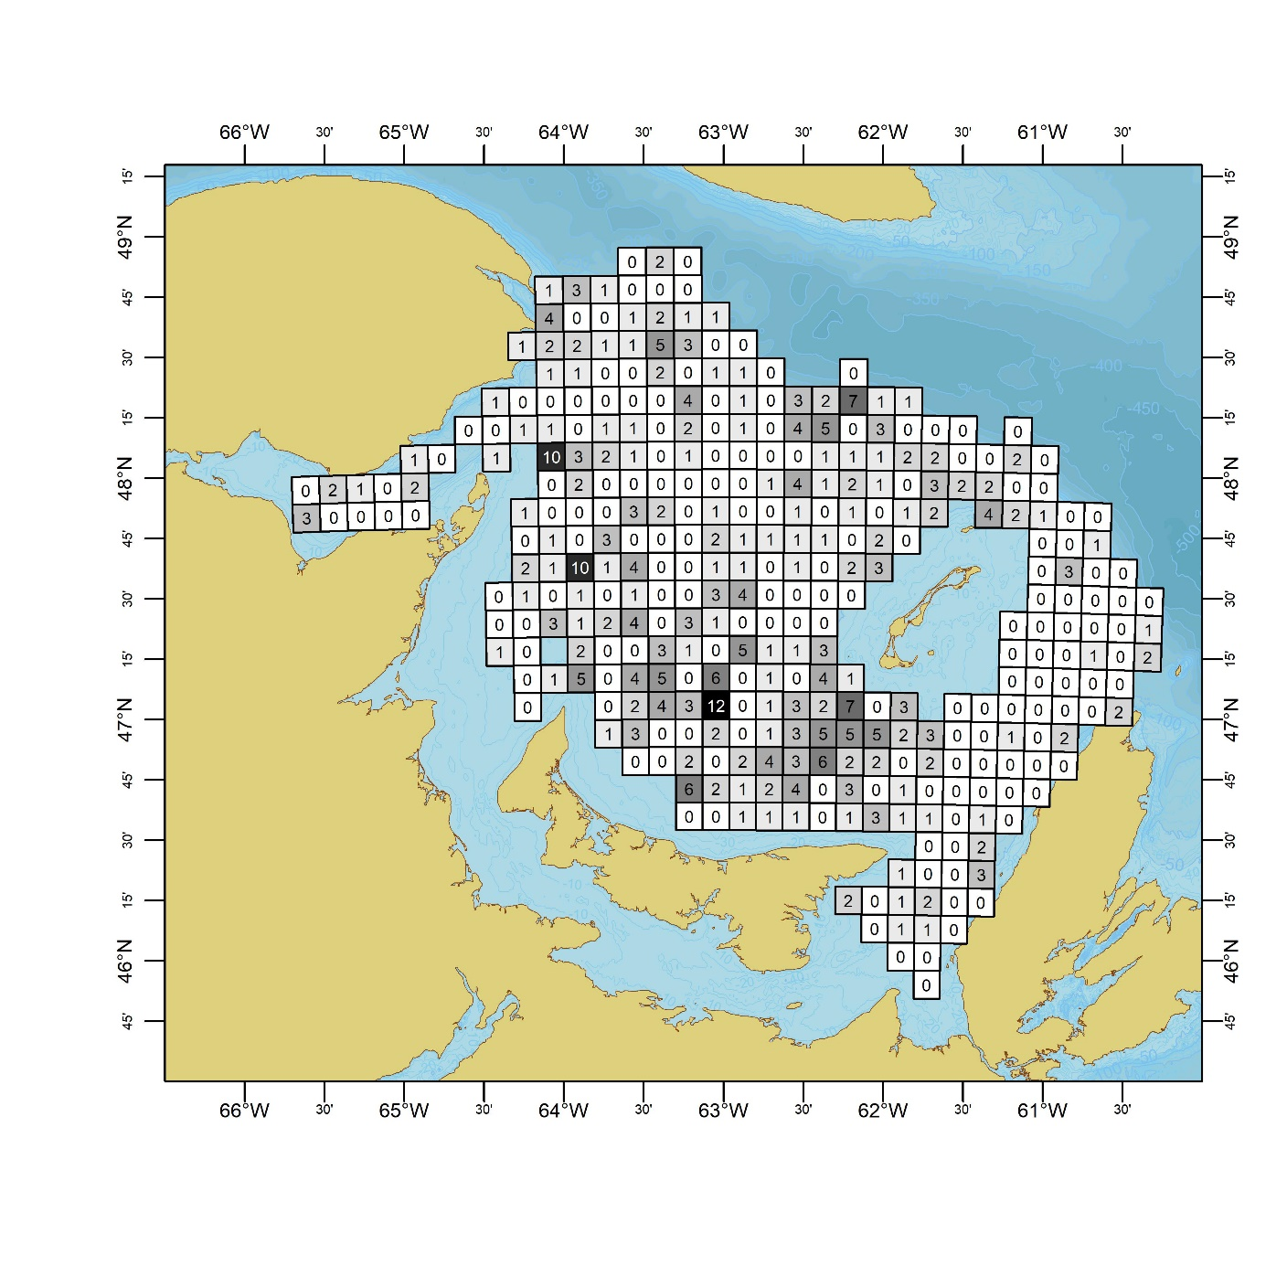

**Figure 4 :** Map of survey sampling grids and the total number of sampling station relocations which have occurred within them over survey years 2013-2019.

**TABLES**

**Table 1** : Survey vessel and sampling summary. Shaded areas represents blocks of similar survey designs from 2006 onwards.

|  |  |  |  |  |  |  |
| --- | --- | --- | --- | --- | --- | --- |
| **Year** | **Vessel** | **Horsepower** | **Survey grid** | **Stations** | **Sampling** | **Survey area** |
| 1988 | Emy Serge D. | 375 | 10'x10' | 152 |  | - |
| 1989 | Emy Serge D. | 375 | 10'x10' | 155 |  | - |
| 1990 | Emy Serge D. | 375 | 10'x10' | 162 |  | - |
| 1991 | Emy Serge D. | 375 | 10'x10' | 177 | new stations | - |
| 1992 | Emy Serge D. | 375 | 10'x10' | 233 |  | - |
| 1993 | Emy Serge D. | 375 | 10'x10' | 208 |  | - |
| 1994 | Emy Serge D. | 375 | 10'x10' | 259 |  | - |
| 1995 | Emy Serge D. | 375 | 10'x10' | 261 |  | - |
| 1996 | Emy Serge D. | 375 | 10'x10' | 72 | partial | - |
| 1997 | Emy Serge D. | 375 | 10'x10' | 259 |  | - |
| 1998 | Emy Serge D. | 375 | 10'x10' | 261 |  | - |
| 1999 | Den C. Martin | 402 | 10'x10' | 277 |  | - |
| 2000 | Den C. Martin | 402 | 10'x10' | 280 |  | - |
| 2001 | Den C. Martin | 402 | 10'x10' | 292 |  | - |
| 2002 | Den C. Martin | 402 | 10'x10' | 319 |  | - |
| 2003 | Marco-Michel | 660 | 10'x10' | 317 |  | - |
| 2004 | Marco-Michel | 660 | 10'x10' | 347 |  | - |
| 2005 | Marco-Michel | 660 | 10'x10' | 355 |  | - |
| 2006 | Marco-Michel | 660 | 10'x10' | 354 | new design | 44302 |
| 2007 | Marco-Michel | 660 | 10'x10' | 355 |  | 44302 |
| 2008 | Marco-Michel | 660 | 10'x10' | 355 |  | 44302 |
| 2009 | Marco-Michel | 660 | 10'x10' | 355 |  | 44302 |
| 2010 | Marco-Michel | 660 | 10'x10' | 354 |  | 44302 |
| 2011 | Marco-Michel | 660 | 10'x10' | 353 |  | 44302 |
| 2012 | Marco-Michel | 660 | 13.1 x 13.1 km | 321 | new design | 57840 |
| 2013 | Jean-Mathieu | 720 | 12.6 x 12.6 km | 352 | new stations | 57840 |
| 2014 | Jean-Mathieu | 720 | 12.6 x 12.6 km | 353 |  | 57840 |
| 2015 | Jean-Mathieu | 720 | 12.6 x 12.6 km | 353 |  | 57840 |
| 2016 | Jean-Mathieu | 720 | 12.6 x 12.6 km | 354 |  | 57840 |
| 2017 | Jean-Mathieu | 720 | 12.6 x 12.6 km | 353 |  | 57840 |
| 2018 | Jean-Mathieu | 720 | 12.6 x 12.6 km | 354 |  | 57840 |
| 2019 | Avalon Voyager II | 850 | 12.6 x 12.6 km | 352 |  | 57842.8 |
| 2020 | Avalon Voyager II | 850 | 12.6 x 12.6 km | 353 |  | 57842.8 |

**Table 2:** Number of survey grids, out of a total of 355, having had a specified number of survey stations moved since 2013.

|  |  |  |  |  |  |
| --- | --- | --- | --- | --- | --- |
| **Year** | **0** | **1** | **2** | **3** | **4+** |
| 2013 | 288 | 57 | 9 | 1 | 0 |
| 2014 | 261 | 75 | 13 | 6 | 0 |
| 2015 | 237 | 79 | 25 | 12 | 2 |
| 2016 | 226 | 77 | 28 | 16 | 8 |
| 2017 | 217 | 76 | 26 | 25 | 11 |
| 2018 | 206 | 76 | 30 | 29 | 14 |
| 2019 | 195 | 78 | 28 | 28 | 26 |
| 2020 | 186 | 80 | 33 | 29 | 27 |

**Bibliography:**

Moriyasu, M., Wade, E., Hébert, M. and Biron, M. 2008. Review of the survey and analytical protocols used for estimating abundance indices of southern Gulf of St. Lawrence snow crab from 1988 to 2006. DFO Can. Sci. Advis. Sec. Res. Doc. 2008/069.

**Catch comparisons:**

* For the purposes of annual comparisons, animal counts were analyzed using a Poisson count model with a random effect over survey grids.
* Annual densities over the sampled grids were obtained from the model, as well as density estimates for each sampled grid in a given survey year.
* The survey grid scheme which is currently used was used to spatially disaggregate data from 2006 to 2020.
* As the survey area from 2006-2011 was smaller than the current survey area, we expect that this portion of the series may not be comparable. With this in mind, we mostly expect that the densities over this period would be on a slightly higher scale than 2012-2020, as the later survey expansion was mostly into more marginal habitat for snow crab and most by-catch species.
* *There is now an extended period of a positive residual pattern between the survey and predicted R1 biomass, effectively since about 2012 and constituting near-half of the time series.* 
  + R1s are affected by by-catch mortality from fishing
  + R1s are subject to variations in natural mortality thought to be driven by high abundance of large commercial males (residuals)
  + Catchability is also an issue.
* A new survey design was instituted in 2012 with expanded boundaries and new site selection.
* Since 2013, there has been a practice to maintain successful sets from the previous survey and abandon unsuccessful sets in lieu of successfully occupied alternates.
* My guess is the successful alternates that become a fixed part of the survey design thereafter *would be systematically associated with softer substrates, upon which q would be higher (intro of trawl survey document says footrope digs into soft-sediment and increases q.*
* Survey Protocol section of Trawl Document says in 2018 31 stations (= near 10% of total survey) were re-assigned in 2019 survey design. Furthermore, the Characteristics of Tows in 2019 section says an additional 33 sites were completed on additional stations. This is a high rate of attrition, presumably toward softer sediments.
* Figure 7 in the trawling document suggests it’s mostly peripheral areas that are becoming abandoned. This pattern is even more exacerbated in previous assessment documents, such as in 2013-2015 survey years.
* The increasing attrition of shallow/hard bottom areas and increasing prominence of deeper/softer areas would lead to decreased presence of what would typically conform to small crab habitat and increased presence of what would typically conform to larger crab habitat and ultimately increase overall survey q, particularly for large crab (Mullowney review document on crab distribution and migration - Reviews Fish Biology & Fisheries).
* Potential issues of increasing survey q are also consistent with a pattern of increasing vessel horsepower on the survey vessels throughout the time series (ie. Benoit and Cadigan documents on the catchability of the RV vessels).
  + Benoit and Cadigan estimated a fairly large decrease in relative catchability between the Marco Michel (2012) and the Jean Mathieu (2013), although the Jean Mathieu had a more powerful engine, with 720hp versus 660hp.
  + CFVs Marco Michel and Avalon Voyager II have similar designs, with both having higher centers of gravity than the lower-lying Jean Mathieu.
* There is a flat or negligibly positive slope on the 34-44mm CW crab index since 2006. In contrast, larger crab stages R4-R1, which inform the stage-based model have more strongly increasing slopes. The document claims the model starts at 56-68mm CW because of decreasing trawl catchability at lower sizes, but this would not seem to explain the disconnect between the stages if there is a constant survey q at each stage over time.
  + Perform analysis using size-based categories, e.g. 95-110mmm versus instar VIII
* Trends in American Plaice capture in this survey appear consistent with an increasing survey q over the time series.
  + American Plaice abundance seemingly increased in abundance from 2006 to 2011. This survey period had a consistent set of stations and a single survey vessel and crew.
  + *Use the same scaling method to recalculate the American Plaice length-frequencies.*
  + The 2012 survey redesign saw a decrease in abundance with another comparable one in 2013, with a new set of survey stations and survey vessel. The period from 2013-2018 was relatively much lower compared to the high point in 2012. A moderate increase in abundance was observed over this period, though a small decrease in 2017 to 2018 was also observed.
  + 2019 saw a large significant increase of ~22% over 2018. The 2020 level was comparable to 2019.
  + However, length-frequencies show a recruitment pulse starting in 2018 through 2020 which affect the perceived relative abundance over these years.
* Priors used in the stage-based model come from a period of suspected lower survey q.
* Fig. 15 in the fishery document shows a loose positive correlation between biomass and CPUE over the time series (probably significant, not sure). Yet, CPUE in Area 12, the major crab area, has been flat for a decade and actually down in the past two years. This doesn’t appear to be associated with a trap saturation point, as other areas are/have shown higher CPUE.
* If I understand Fig. 11 and Fig 12. correctly, annual m for new-intermediate hard-shelled large adult males would be about 0.2-0.4 = Zm(0.2-0.5). This seems kinda high? I don’t see why a crab in its prime physical condition, virtually immune from predation, would have m this high? I could see if it was more relevant to older-shelled or smaller crab. All above points on increasing survey q would suggest exploitation rate is probably higher than suggested.

Snow crab trends:

* The survey from 2006 to 2011 used the same sampling design, fixed stations and the same survey vessel and crew. As such, inter-annual comparisons over this period are less prone to some sampling biases which were identified, such as vessel effects and moving stations to more trawlable areas, which were present from 2012 to 2020.
* Annual trends for three snow crab categories were examined, immature females, mature females, immature males and commercial males.
  + Add commercial crab to analysis.
  + Over the period of 2006 to 2011, snow crab densities increased for all categories.
  + In 2012, densities remained comparable to 2011, except for mature females which increased by more than 20%.
  + In 2013, densities for all categories decreased by significant amounts: ~45% for immature females, ~25% for mature females, ~20% for immature males, and X% for commercial males.
  + During the period from 2013 to 2018, immature females saw a large increase of ~45% in 2016. Mature females saw gradual increases of 5-10%, immature males saw moderate increases in 2014 and 2015, and a large increase of ~35% 2018.
  + With the vessel change in 2019, densities saw large increases of almost 50% for immature females, almost 40% for mature females, 35% for immature males and X% for commercial males.
  + Survey year 2020 saw moderate increases of ~10% for mature females and immature males.